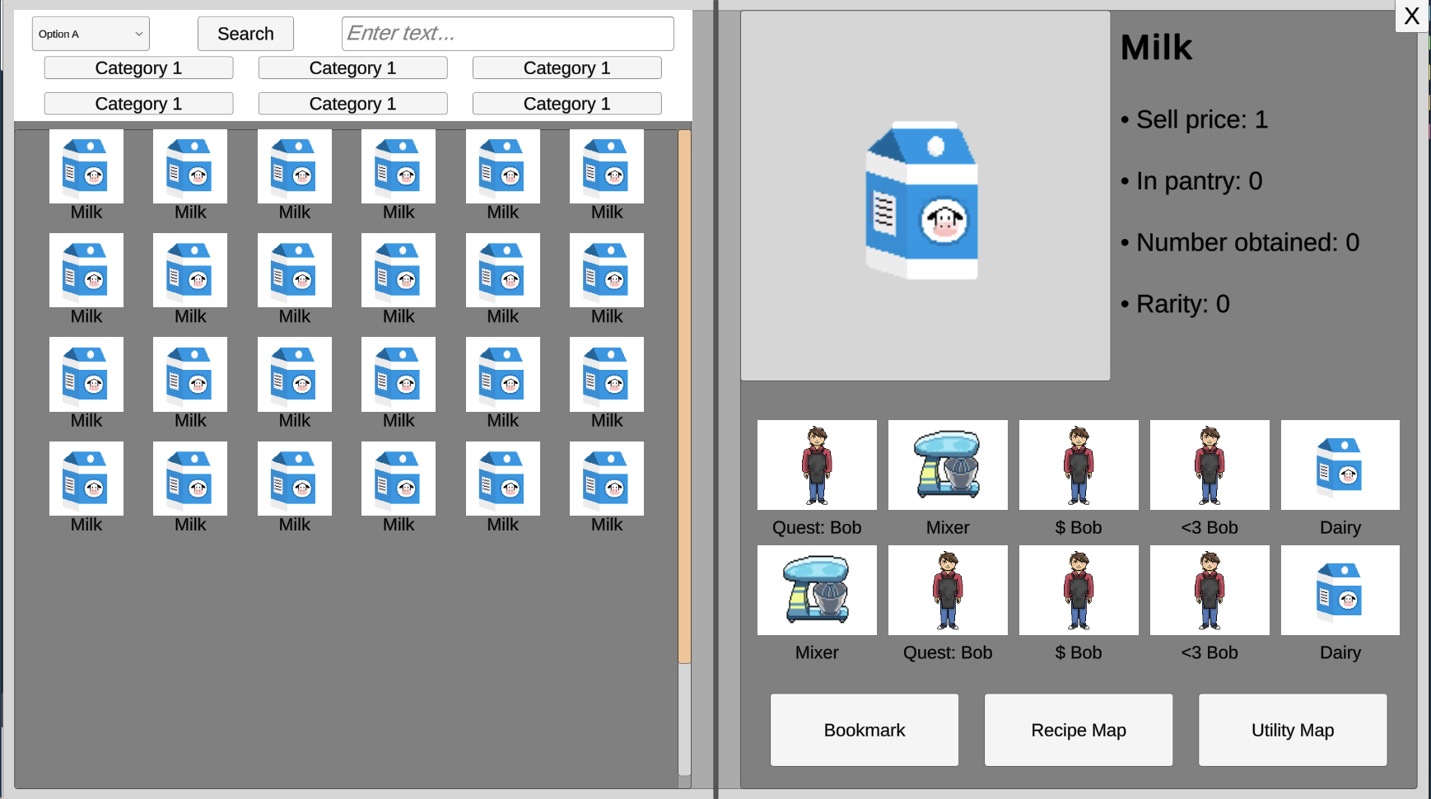

Simmer Design Document: Recipe Book

### Key:

* *Ingredient* : raw ingredients, intermediate items (ex. Cake batter), finished cake
* *Ingredient Knowledge* : tied to recipe book to allow visualization of recipe to player

# Visual Representation - UI

* [Left-hand side] Icon grid
* [Right-hand side] Specific information to selected item

Example:

1. Player opens recipe book
2. All known recipes and ingredients are shown on left hand side
   1. Ordered by:
      1. Recipes (alphabetical order)
      2. Ingredients (alphabetical order)
3. Selecting an item will show available information
   1. All items once selected will have the option to display maps of their interaction connections.
      1. Recipe Map - Shows all steps necessary to acquire this item
         1. If its a raw ingredient, shows one connection to the market seller
      2. Utility Map - Shows all possible uses of this ingredient
         1. If it's a final recipe that can’t be further used, connects to a generic sell/quest node
   2. Any undiscovered node or edge on these maps will be grayed out

# Software Interaction - UX

* Checking *ingredient knowledge*
* Checking known *ingredients*

# Search Functionality

* Ingredients
  + “Raw Ingredients”
* Intermediate Items
  + “Complexity “ 1, 2, 3
* Base implementation for filter tabs: raw ingredients, final ingredients, all ingredients